Guide to completing questionnaires for Ofsted visit to East Coast College
Dear parent/employer/student
Thank you for taking part in this questionnaire as part of our current Ofsted inspection. Below is a step by step guide to completion. The questionnaire consists of 12 questions and should only take a couple of minutes to complete.
The parent questionnaire will be accessible during the inspection which commences on Tuesday 15th May 2018.
Step 1. Please select the appropriate link from the list below depending on your relationship with the college:
https://parentview.ofsted.gov.uk
https://learnerview.ofsted.gov.uk
https://employerview.ofsted.gov.uk
Step 2.
Click on the orange “jigsaw” piece saying “Give your views now”.
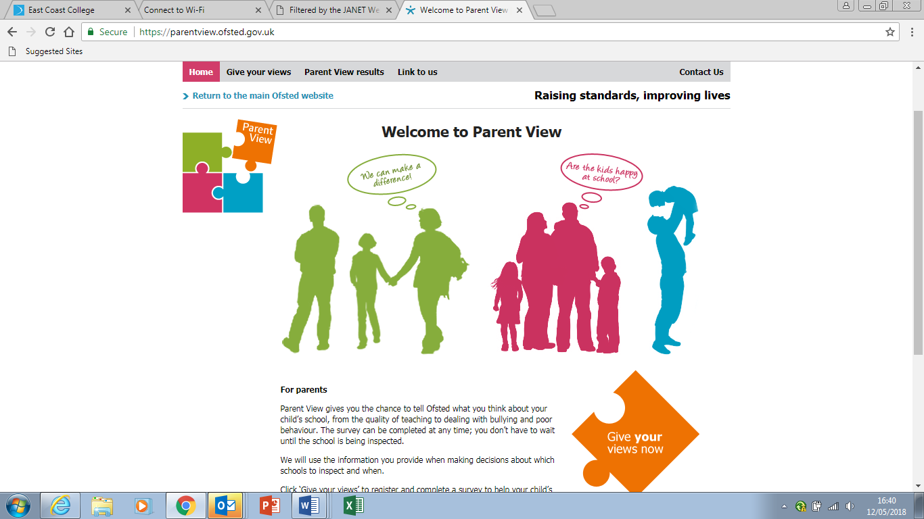
Click to Register using the link provided.
Register screen below:
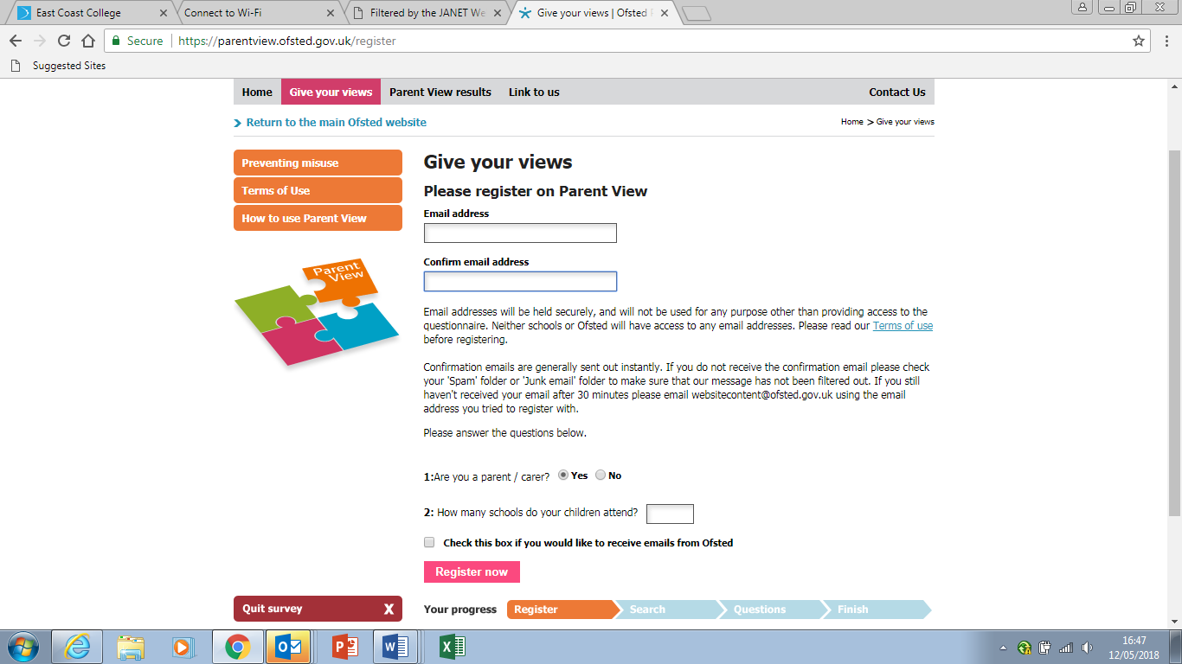

Once registered, you will be sent a “one use only” link to re-enter the site.
Enter your email address again and password as instructed.
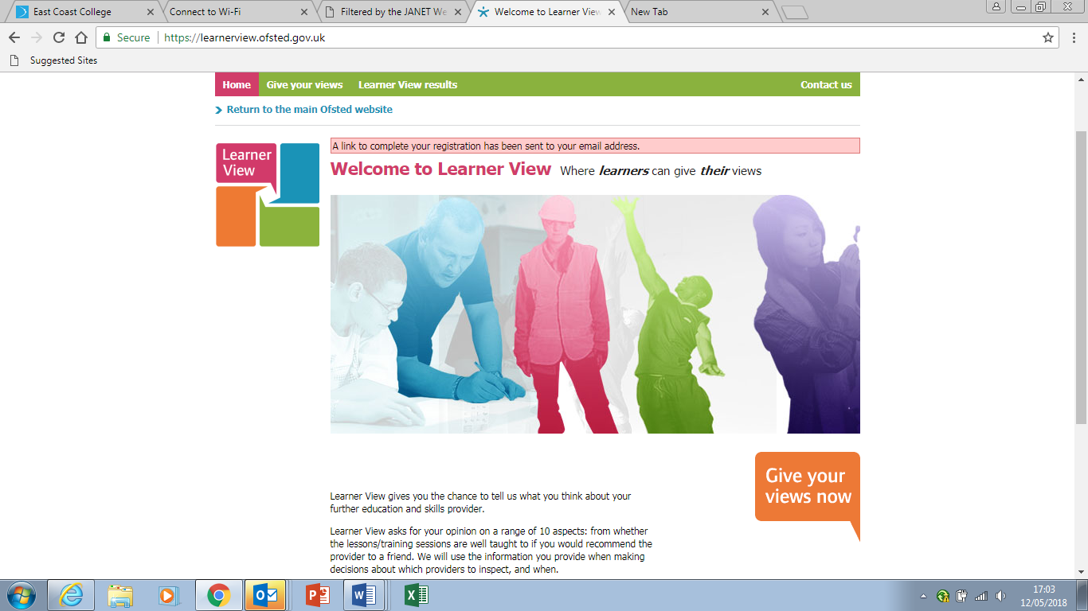
Click on “Give your views” and enter the URN: 130819 in the box provided or Lowestoft under location. East Coast College should appear as an option. Click on the college name to enter the questionnaire.

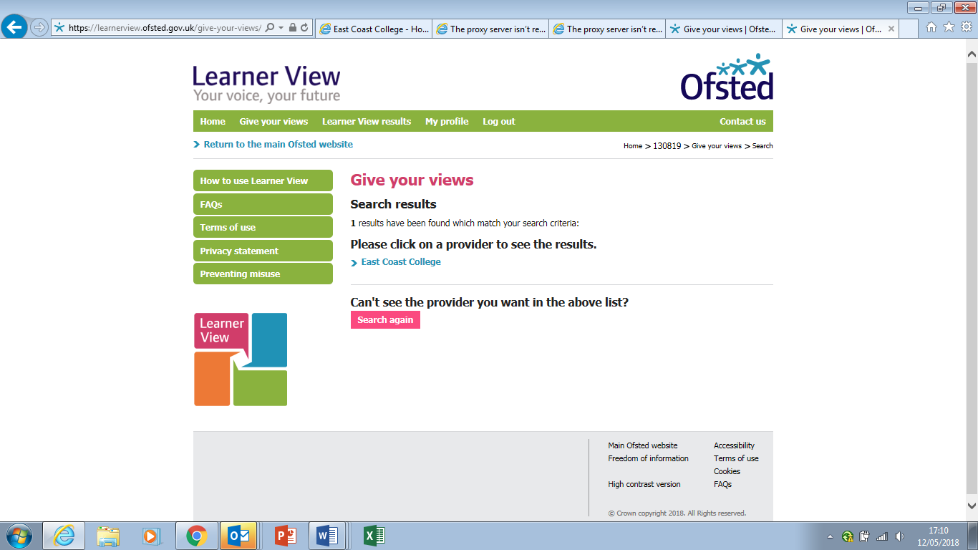
Step 3. Complete questionnaire as instructed
Step 4. Finish/submit
Thank you for sharing your views.

