****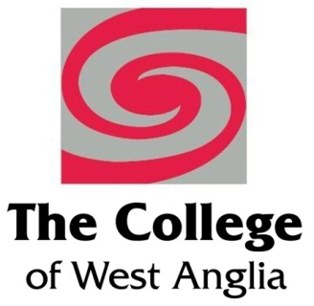 

**Emerging Leaders**

**Developing management skills within the voluntary and community sector**

Welcome to East Coast College and the Emerging Leaders Programme delivered in partnership with College of West Anglia and funded through European Social Fund.

The programme is designed to support potential managers and leaders working in the voluntary sector to develop skills and knowledge to support and manage project applications effectively.

Summary of course – 6 **workshop sessions** with assignments embedded in the workplace, 1-1 tutorial and workplace assessments.

**Workshop 1** Induction & Tips for good bid writing/project applications

Strategic reviews and plans.

**Workshop 2** Project and business planning.

**Workshop 3** Workforce development.

**Workshop 4** Impact demonstration.

**Workshop 5** Partnerships and procurement.

**Workshop 6** Financial strategies

On successful completion of the course you will receive a College certificate listing the units achieved.

*To be eligible for ESF funding you need to be able to answer* ***yes*** *to the following 4 questions:*

* Is your business based in Norfolk or Suffolk?
* Do you have less than 250 employees?
* Is the identified member of staff over 19 years of age?
* Would you like to enhance their leadership skills?

If you have answered **yes** to all 4 questions, we have the perfect training plan ….

We realise that financing staff training can be challenging for smaller companies, which is why East Coast College in partnership with local regional colleges are offering the Skills Support for Emerging Leaders project, delivering training funded, or part-funded, by the European Social Fund (ESF).

The fund can deliver skills training to your employees who are aged 19 or over, who have lived in the EU for the last 3 years and who are seen as ‘emerging leaders’ in your organisation.

To ensure the training meets your needs, we carry out a 3-stage ‘skills health’ check before training begins – **this is completely free of charge**. This will identify business skills needs to ensure we meet the aspirations and vision of the business, as well as identify skills gaps for those employees showing potential to progress to team leader, supervisor or management positions.

The funding is available for employees completing programmes before **31st March 2019** and will enable the dedicated support of up to 330 emerging leaders across the New Anglia Local Enterprise Partnership area.

The course is planned to start in late September 2018 and finish in January 2019

For more information, please contact Kevin Bayes at [k.bayes@eastcoast.ac.uk](mailto:k.bayes@eastcoast.ac.uk) or Ferlin Quantrill at [f.quantrill@eastcoast.ac.uk](mailto:f.quantrill@eastcoast.ac.uk)