****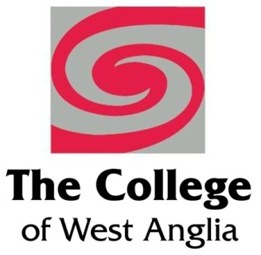 

**Emerging Leaders**

**Option 2: Project Management, Skill Development**

Welcome to East Coast College and the Emerging Leaders Programme delivered in partnership with College of West Anglia and funded through European Social Fund.

The programme is designed with to help you to understand how to be an effective leader, improve the performance of your team which in turn will improve productivity or service delivery for your organisation.

**Objective** – to give an understanding of the importance of leadership in the management role and the key skills required

Summary – **4 days training** delivery, 2 workshops and 2 assessed through assignments

**Objective –** to give an understanding of the key skills and knowledge required to set and deliver small scale projects in the workplace

**Day 1 Workshop**

Induction

Managing workplace projects

* Know how to manage a simple workplace project
* Understand the financial and non-financial implications of a workplace project

**Day 2 Assessed module**

Introduction to assignment writing – hints, tips and techniques

Solving problems & making decisions

* Know how to describe a problem, its nature, scope and impact
* Know how to gather and interpret information to solve a problem
* Know how to evaluate options to make a decision
* Know how to plan, monitor and review the implementation and communication of decisions

**Day 3 Assessed module**

Planning change in the workplace

* Understand the forces for change in an organisation
* Know how to identify and plan change in an organisation

**Day 4 Workshop**

Understanding the impact on people

* Consider the impact of leadership styles on performance, productivity and motivation
* Understand the effects of innovation and change on people and teams in an organisation

*To be eligible for ESF funding you need to be able to answer* ***yes*** *to the following questions:*

* Is your business based in Norfolk or Suffolk?
* Do you have less than 250 employees?
* Is the identified member of staff over 19 years of age?
* Would you like to enhance their leadership skills?

If you have answered **yes** to all 4 questions, we have the perfect training plan ….

We realise that financing staff training can be challenging for smaller companies, which is why East Coast College in partnership with local regional colleges are offering the Skills Support for Emerging Leaders project, delivering training funded, or part-funded, by the European Social Fund (ESF).

The fund can deliver skills training to your employees who are aged 19 or over, who have lived in the EU for the last 3 years and who are seen as ‘emerging leaders’ in your organisation.

To ensure the training meets your needs, we carry out a 3-stage ‘skills health’ check before training begins – **this is completely free of charge**. This will identify business skills needs to ensure we meet the aspirations and vision of the business, as well as identify skills gaps for those employees showing potential to progress to team leader, supervisor or management positions.

The funding is available for employees completing programmes before **31st March 2019** and will enable the dedicated support of up to 330 emerging leaders across the New Anglia Local Enterprise Partnership area.

For more information, please contact Kevin Bayes at [k.bayes@eastcoast.ac.uk](mailto:k.bayes@eastcoast.ac.uk) or Ferlin Quantrill at [f.quantrill@eastcoast.ac.uk](mailto:f.quantrill@eastcoast.ac.uk)