****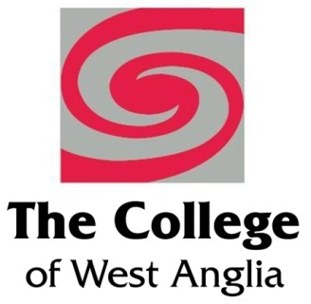 

**Emerging Leaders**

**People Management Skill Development**

Welcome to East Coast College and the Emerging Leaders Programme delivered in partnership with College of West Anglia and funded through European Social Fund.

The programme is designed with to help you to understand how to be an effective leader, improve the performance of your team which in turn will improve productivity or service delivery for your organisation.

**Objective** – to give an understanding of the importance of leadership in the management role and the key skills required

Summary – **4 days training** delivery, 2 workshops and 2 assessed through assignments

**Day 1 Workshop**

Induction

**Developing yourself & others**

• Know how to identify development needs

• Know how to develop self and others to achieve organisational objectives

**Understanding leadership**

• Understand leadership styles

• Understand leadership qualities and review own leadership qualities

**Day 2 Assessed module**

Introduction to assignment writing – hints, tips and techniques

The communication process

• Understand the nature and importance of the communication process in the workplace

• Understand the methods of communication

• Be able to assess own effectiveness in communication

**Day 3 Assessed module**

Motivate to improve performance

• Understand the factors that influence motivation levels in the workplace

• Understand how a theory of motivation can be used to improve performance levels

• Self-perception survey to identify how motivated and engaged the learners are

**Day 4 Workshop**

Establishing an effective team

• Understand how to develop and maintain effective working relationships

• Understand how to build a team

• Motivational Mapping for teams

*To be eligible for ESF funding you need to be able to answer* ***yes*** *to the following questions:*

* Is your business based in Norfolk or Suffolk?
* Do you have less than 250 employees?
* Would you like to enhance their leadership skills?

If you have answered **yes** to all 3 questions, we have the perfect training plan ….

We realise that financing staff training can be challenging for smaller companies, which is why East Coast College in partnership with local regional colleges are offering the Skills Support for Emerging Leaders project, delivering training funded, or part-funded, by the European Social Fund (ESF).

The fund can deliver skills training to your employees who are aged 19 or over, who have lived in the EU for the last 3 years and who are seen as ‘emerging leaders’ in your organisation.

To ensure the training meets your needs, we carry out a 3-stage ‘skills health’ check before training begins – **this is completely free of charge**. This will identify business skills needs to ensure we meet the aspirations and vision of the business, as well as identify skills gaps for those employees showing potential to progress to team leader, supervisor or management positions.

The funding is available for employees completing programmes before **31st March 2019** and will enable the dedicated support of up to 140 emerging leaders across the New Anglia Local Enterprise Partnership area.

For more information, please contact Kevin Bayes at [k.bayes@eastcoast.ac.uk](mailto:k.bayes@eastcoast.ac.uk) or Ferlin Quantrill at [f.quantrill@eastcoast.ac.uk](mailto:f.quantrill@eastcoast.ac.uk)